**Data-Flow Diagrams for RC Mode – Pi**

**During setup**

Driver uses PuTTY to SSH into the Raspberry Pi

Driver uses the RPi terminal to execute the drive command

The drive command enables a web browser that will allow the user to control certain settings of the car and see through the camera

**During Driving**

Pi receives that signal and sends it through the motor controller, which results in the vehicle driving!

Nano-receiver sends that signal to the laptop through USB port

Controller sends that joystick signal to its respective nano-receiver

Driver moves the joystick

Laptop sends that signal through to the SSH session controlling the Pi and to the web browser

**During Training**

Driver drives around track, collecting data in the form of photos and values that are put into a folder, or “tub”

With a “drive model” command, the car begins driving, using the model as a reference for how it should respond to the environment or “track”

This “model” is transferred back to the Pi via USB or SSH commands

With a “train” command, the laptop takes and analyzes the data to create a model of how the car should run based on your movements

The “tub” of data is transferred from the Pi to the laptop via USB memory stick or SSH commands

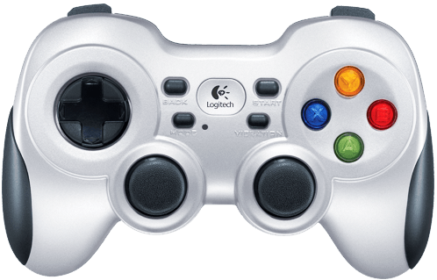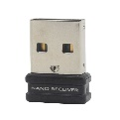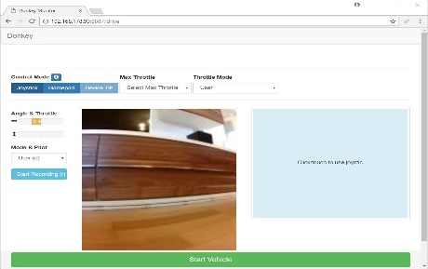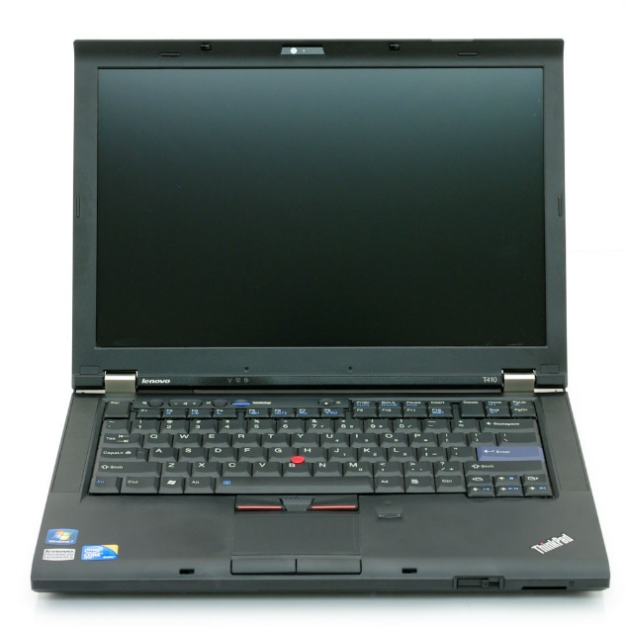 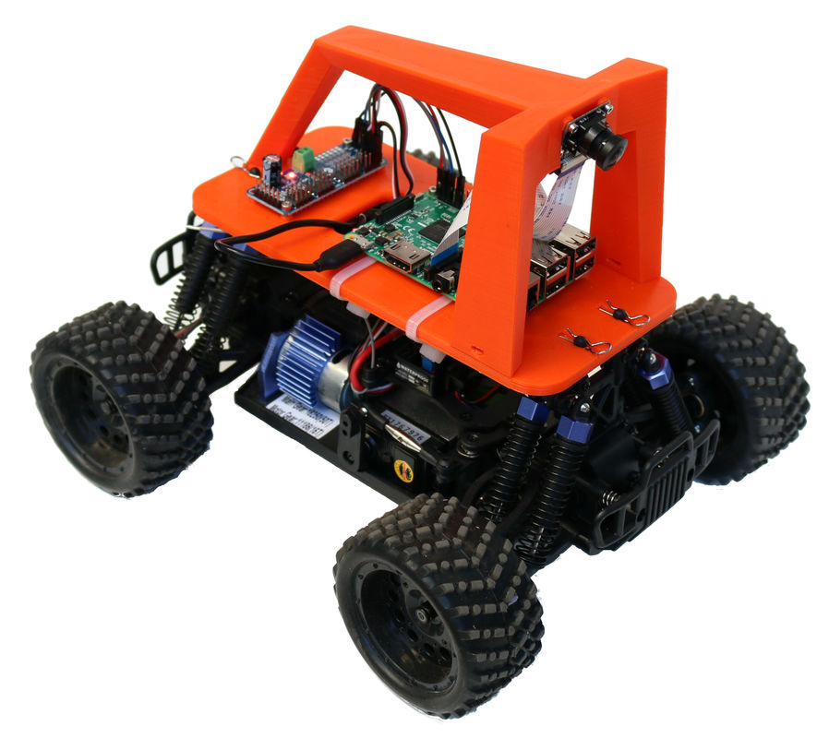

See the source imageSee the source image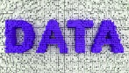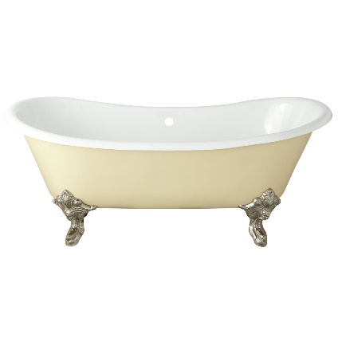

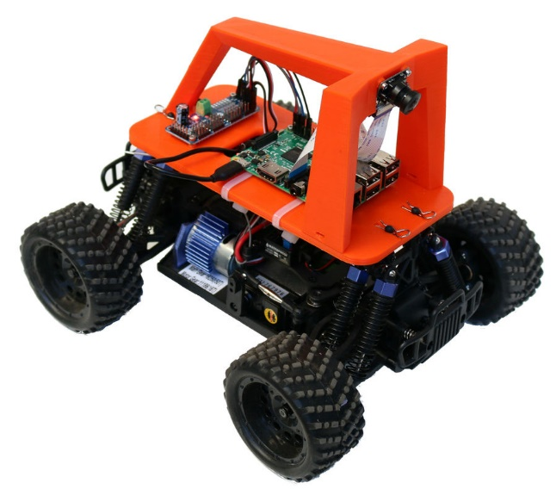See the source imageSee the source imageSee the source image